**Use test – Demonstrate the buggy behavior**

The Hotel Booking System use case test performs to demonstrate the buggy behavior of the Hotel Booking System in User Acceptance Testing form.

There are two bugs are reported as following:

1. All Service charges are reported as $0.00 when checking out.
2. It is possible to charge a room for service after the guest has checked out.

| **Test Name** | Hotel Booking System - Use Case Test |
| --- | --- |
| **Use Case Tested:** | Hotel Booking System |
| **Test Description:** | The use case of the Hotel Reservation System to test the functionality of the entire hotel booking system is used. This software can be used by the user for hotel services such as room reservation or other hotel services. First, the user can book a room and get a confirmation number for the booking required for registration. Once registered, the user can add other hotel services by choosing a particular service. Upon leaving, the user may pay the full amount, including additional services. |
| **Pre-conditions** | First of all, main menu displays to the User of Hotel Booking System where user can choose the option to proceed further. |
| **Post-conditions** | 1. Scenarios of Hotel Booking System which are working successfully are:  * The user can book a room. * User can check In. * User can add other services.  1. All other unsuccessful scenario are:  * At the time of Check Out, entries of Extra added services are zero.   Other problem is charges of the other services provided to the customers are only getting paid at the time of Check Out. |
| **Notes:** | **Customer may be have extra services by the hotel but the cost of Extra Services are not included to the final bill.** |
| **Result (Pass/Fail/Warning/Incomplete)** | **Failed** |

|  | **TEST STEP** | **EXPECTED TEST RESULTS** | P | F |
| --- | --- | --- | --- | --- |
|  | User can book a room | * Able to enter the booking details to the system. * Choose which type of room and enter necessary details. | Yes | No |
|  | User can check in | * Able to enter confirmation number. * Able to confirm check in. | Yes | No |
|  | Add other services | * Able to choose services. * Able to enter the cost. | Yes | No |
|  | Check out | * Able to enter the room number and details of room should display * Total bill displayed including the extra service charges. | No | Yes |

Following screenshot demonstrate the first reported bug:

Test results are failed because of buggy behavior of the Hotel Booking System.

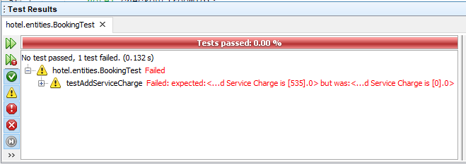

Following screenshot demonstrate the second reported bug:

Test results are failed because of buggy behavior of the Hotel Booking System.

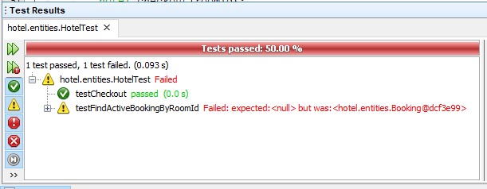

**Debugging log**

To track program bugs, Netbeans IDE used the hotel reservation system and executes it as a debug mode to find the code that is causing the buggy behavior in the system. The following table shows the failed stream.

|  |  |
| --- | --- |
| **Display main menu again – Record service** | |
|  | 1. Able to choose the one of the providing options which are B, C, R, D or Q. |
| 1. Type (R) for record services | 1. Display following:  * Display services types * B: Bar Fridge * R: Restaurant * S: Room Service * Prompt to enter service type |
| 1. Enter service type | 1. Prompt to enter service cost |
| 1. Enter service cost | 1. Display following:  * Services details including cost * **Store cost value.** |
| 1. Hit <enter> to continue | 1. Record service completed |
| **Display main menu again – Checking out** | |
|  | 1. Able to choose the one of the providing options which are B, C, R, D or Q. |
| 1. Type (D) for check out | 1. Able to enter room number |
| 1. Enter room number | 1. Display following:  * Display booking details * Display service charges cost **$0.00** * Display total cost **$0.00** * Prompt to accept charges? (y/n) * **Remove the room from the active booking list.** |
| 1. Enter (y) to accept charges | 1. Show the Cost and allow to enter Card Details to pat bill. |
| 1. Enter credit card details | 1. Display debited amount **$0.00**. |
| 1. Hit <enter> to continue | 1. Display checking out completed. |

**Output of each reported bug**

**First reported bug - Record services cost shows $0.00 on checking out:**

The normal flow is needed to show the correct costs, not $ 0.00 on Checkout.

The use of the variable is not correct, so the costs incurred did not relate to the method that could have kept the value and the result of the device test was also unsuccessful.

**Unit test output:**

The test result is unsuccessful due to bug behavior because the method does not store the value so the expected and actual results are different.



**Source code screenshot:**

The error is highlighted in the following screenshots. The addServiceCharges () method stores only the type of service, not the price, as output is the only type of service, but the cost of services is $ 0.00

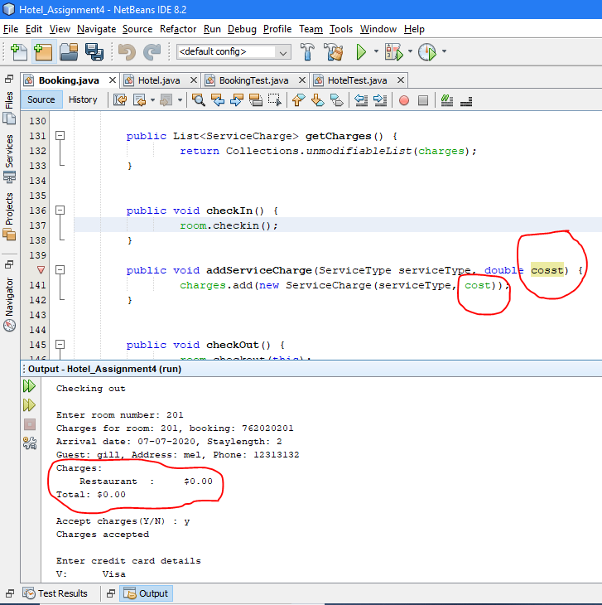

**Second reported bug - It is possible to charge a room for service after checked out.**

The normal flow is necessary to not show a reservation available for the relevant room with record service for the guest that has checked out. The implementation of the method is not correct, so the room remains active after checking, but it must be removed from the active list and the test results of the unit have failed for the same reason.

**Unit test output:**

The test result failed because of bug behavior because the removal method does not remove the interval from the active list. Therefore, the testFindActiveBookingByRoomID () method is still active because the test did not succeed as expected and the actual result is different.



**Source code screenshot:**

In the following screenshots the error is highlighted. At present, checkout() method does not remove the room from the active booking list as checkin() method add(put) the room in the active list that is why it is possible to charge for any services after the guest has checked out as the room never remove from the active list.

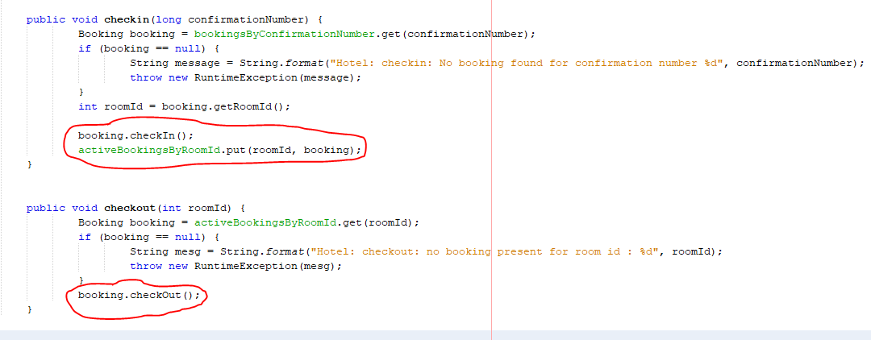

**Output demonstrating correct operation**

**Fixed first reported bug - Record services cost shows $0.00 on checking out:**

The first bug has been fixed by changing the variable name in the addServiceCharge() method which is located in the Booking class of the Hotel Booking System. Now, record service not showing $0.00 however it is showing actual cost as following source code output:

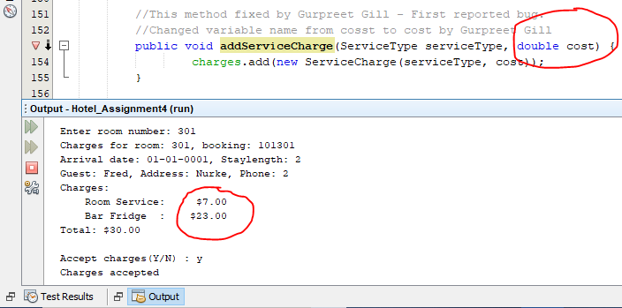

**Unit test output:**

The test result is passed after fixing the method.

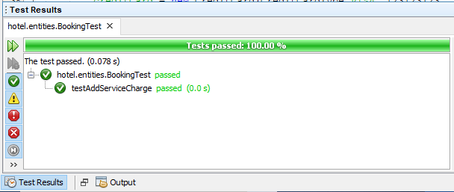

**Second reported bug - It is possible to charge a room for service after checked out.**

The second error was corrected by updating the payment method (), which is in the hotel class of the hotel reservation system. It is not possible to request the Room service after it has been checked as the following output of the source code:

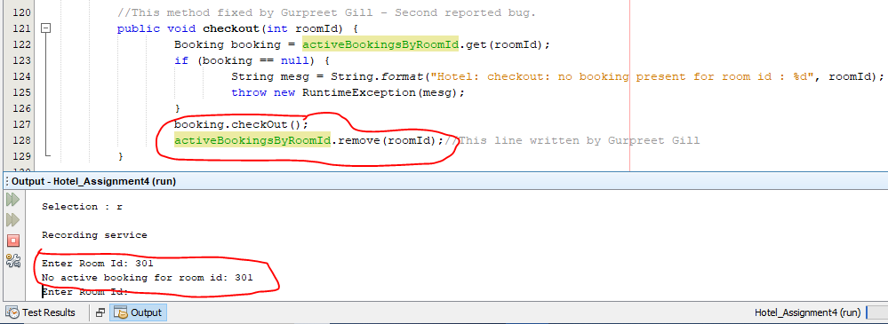

**Unit test output:**

The test result is passed after fixing the method.

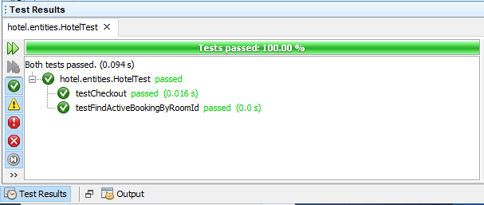

**GitHub feature branch folder link:**

<https://github.com/tgcsu515/Assignment4_HotelReservationSystem/tree/11626472_ArashdeepKaur/src/hotel>